KWAME NKRUMAH UNIVERSITY OF SCIENCE AND TECHNOLOGY
DEPARTMENT OF COMPUTER SCIENCE


An AI-Powered Job Search and Recruitment Platform

DOCUMENTED BY:
NAME INDEX NUMBER
DESMOND OWUSU BOBIE 3409422

SUPERVISED BY:
DR. DOMINIC ASAMOAH
Table of Contents
ABSTRACT 3
CHAPTER ONE 4
INTRODUCTION 4
1.1 Background of the Project 4
1.2 Statement of the Problem 4
1.3 Proposed System 5
1.4 Main Objective 5
1.5 Specific Objectives 5
1.6 System Functionalities 6
1.7 Results 6
CHAPTER TWO 7
Review Of Related Works 7
2.1 Chapter Overview 7
2.2 Processes of Existing Systems 8
2.2.1 Current Job Search Platforms Available 9
2.3 The Proposed System 9
2.3.1 The Conceptual Design……………………………………………………….9
2.3.2 Architecture Of The Proposed System………………………………………9
2.3.3 Component Design and Component Description………………………….9
2.3.4 System Features ……………………………………………………………...9
2.4 Development Tools and Environment………...……………………………………9
2.4.1 Frontend Development…………………………………………………………9
2.4.2 Backend Development…………………………………………………………9
2.4.3 Database and Storage…………………………………………………………9
2.4.4 Development Tools…………………………………………………………….9
2.4.5 File Handling and Communication……………………………………………9
CHAPTER THREE 10
3.1 Chapter Overview 10
3.2 Requirement Specification 10
3.2.3 Functional Requirements…………………………………………………………11
3.3 Activity Diagrams……………………………………………………………………13
3.4 Non-Functional Requirements…………………………………………………….15
3.5 Project Methods 15
3.6 Development Tools………………………………………………………………….16

CHAPTER FOUR 22
SUMMARY, CONCLUSION AND RECOMMENDATION 22
4.1 Summary 22
4.2 Conclusion 22
4.3 Recommendations 22
References 27

ABSTRACT
JobQuest is a comprehensive web-based job search and recruitment platform that leverages artificial intelligence to bridge the gap between job seekers and employers. The system addresses the inefficiencies in traditional job search processes by providing intelligent job matching, automated resume analysis, and streamlined application management.

The platform is built using modern web technologies including React.js for the frontend, Node.js with Express.js for the backend API, and MongoDB for data persistence. The system implements a dual-role architecture supporting both job seekers (applicants) and employers, with role-based access control and secure authentication mechanisms.

CHAPTER ONE

INTRODUCTION

1.1 Background of the Project

JobQuest is an innovative, AI-powered job search and recruitment platform designed to revolutionize the way job seekers find opportunities and employers discover talent. In today's rapidly evolving job market, traditional recruitment methods have become increasingly inefficient, creating significant challenges for both parties involved in the hiring process.The platform represents a comprehensive solution that leverages modern web technologies and artificial intelligence to create a seamless, intelligent job matching ecosystem. Built using React.js for the frontend, Node.js with Express.js for the backend, and MongoDB for data persistence, JobQuest provides a robust, scalable platform that addresses the core inefficiencies in current job search and recruitment processes.The system implements a dual-role architecture that serves both job seekers and employers, with sophisticated role-based access control and secure authentication mechanisms. Through AI-powered resume analysis, intelligent job matching algorithms, and real-time notification systems, JobQuest aims to significantly reduce the time and effort required for successful job placement while improving the quality of matches between candidates and positions.
1.2 Statement of the Problem
The traditional job search and recruitment process faces numerous challenges that create inefficiencies for both job seekers and employers. Job seekers struggle with:
- Manual job searching across multiple platforms requiring repetitive profile creation
- Lack of intelligent matching between skills and job requirements
- Time-consuming application processes with no standardized resume formats
- Limited feedback on application status and interview processes
- Difficulty in tracking multiple applications across different companies
Employers face challenges including:
- Manual resume screening requiring significant time and resources
- Difficulty in finding qualified candidates that match specific skill requirements
- Lack of standardized application processes across different platforms
- Limited insights into candidate skills and experience
- Inefficient communication channels with applicants

1.3 Main Objective
The primary aim of JobQuest is to develop a comprehensive, AI-powered job search and recruitment platform that streamlines the entire hiring process. The system aims to create a unified ecosystem where job seekers can efficiently find relevant opportunities and employers can identify qualified candidates through intelligent matching algorithms.

1.4 Specific Objectives

Develop a dual-role platform supporting both job seekers and employers with role-based access control

Implement AI-powered resume analysis to extract skills, experience, and qualifications automatically

Create intelligent job matching algorithms that match candidate profiles with job requirements

Build a comprehensive job management system for posting, searching, and applying to positions

Develop real-time notification systems for application updates and job alerts

Implement secure file upload and storage for resumes and company documents

Create responsive dashboard interfaces for both user types with comprehensive analytics

Establish company review and rating systems to enhance transparency

Implement advanced search and filtering capabilities for efficient job discovery

Develop email integration for automated communication between parties

1.5 Project Justification

The project is justified by several critical factors:

Market Need: The global recruitment market is valued at over $28 billion, with increasing demand for digital solutions that reduce hiring time and improve candidate quality.

Technological Gap: Existing platforms lack intelligent matching capabilities and often require manual intervention for optimal results.

Efficiency Benefits: Automated processes can reduce hiring time by 60-70% while improving candidate quality through better matching.

Cost Reduction: Digital recruitment platforms can reduce hiring costs by 30-40% compared to traditional methods.

User Experience: Modern job seekers and employers expect seamless, mobile-friendly platforms with real-time updates.

1.6 Scope of Project

In Scope:

User registration and authentication system

Job posting and management for employers

Job search and application system for job seekers

AI-powered resume analysis and skill extraction

Intelligent job matching algorithms

Real-time notifications and alerts

Company profiles

Dashboard interfaces for both user types

File upload and storage system

Email integration for communications

Responsive web interface

Out of Scope:

Mobile application development

Video interview integration

Background check services

Payment processing for premium features

Integration with external HR systems

Advanced analytics and reporting

Multi-language support

CHAPTER TWO

REVIEW OF RELATED WORKS

2.1 Chapter Overview

This chapter provides a comprehensive analysis of existing job search and recruitment platforms, examining their features, strengths, and limitations. The review serves as the foundation for understanding the current state of the industry and identifying opportunities for improvement in the proposed JobQuest system
2.2 Processes Of Existing System
2.2.1 Current Job Search Platforms Analyisis
LinkedIn
Features:
Professional networking and job posting
Company pages and employee reviews
Skill endorsements and recommendations
Premium subscription model
Pros:
Extensive professional network
Company insights and employee reviews
Integrated messaging system
Mobile application support

Glassdoor
Features:
- Company reviews and salary information
- Interview questions and company insights
- Job posting and application system
- Employer branding tools
Pros:
- Transparent company information
- Salary insights and negotiation data
- Interview preparation resources
- Company culture insights
Cons:
- Limited job matching algorithms
- Focus on reviews rather than job search
- No AI-powered skill analysis
- Limited application tracking

Monster
Features:
- Job posting and search
- Resume database for employers
- Career advice and resources
- Mobile application
Pros:
- Established platform with large user base
- Comprehensive job categories
- Resume database access for employers
- Career development resources
Cons:
- Outdated interface design
- Limited modern features
- No AI integration
- Poor user experience

2.3 The Proposed System
2.3.1 Conceptual Design
JobQuest is designed as a unified platform that combines the best features of existing systems while addressing their limitations. The conceptual design focuses on
Intelligent Matching Engine: AI-powered algorithms that analyze resume content, extract skills, and match candidates with job requirements based on multiple parameters including skills, experience level, location preferences, and salary expectations.
Dual-Role Architecture: A single platform serving both job seekers and employers with role-based access control, eliminating the need for separate systems.
Real-Time Communication: Integrated messaging and notification systems that facilitate direct communication between candidates and employers.
Comprehensive Analytics: Dashboard interfaces providing insights into application status, job performance, and matching effectiveness.

2.3.2 Architecture of the Proposed System
The JobQuest system follows a modern three-tier architecture:Presentation Tier (Frontend)
- React.js-based single-page application
- Responsive design for multiple devices
- Component-based architecture for maintainability
- Real-time updates using WebSocket connections
Application Tier (Backend)
- Node.js with Express.js RESTful API
- Microservices architecture for scalability
- JWT-based authentication and authorization
- Rate limiting and security middleware
Data Tier (Database)
- MongoDB for flexible document storage
- Optimized indexing for search performance
- File storage for resumes and documents
- Backup and recovery systems

2.3.3 Components Designs and Components Descriptions
Authentication Component
Function: Manages user registration, login, and session managementAlgorithm:
- Password hashing using bcrypt with salt rounds
- JWT token generation and validation
- Role-based access control implementation
- Session timeout and refresh mechanisms
Resume Analysis Component
Function: Extracts skills, experience, and qualifications from uploaded resumesAlgorithm:
- Text parsing and keyword extraction
- Skill categorization using predefined taxonomies
- Experience level assessment based on job titles and duration
- Confidence scoring for extracted information
Job Matching Component
Function: Matches candidate profiles with job requirements Algorithm:
- Skill-based matching with weighted scoring
- Experience level compatibility assessment
- Location and salary preference filtering
- Machine learning-based recommendation engine
Notification Component
Function: Manages real-time notifications and email communications Algorithm:
- Event-driven notification system
- Email template generation and delivery
- Real-time WebSocket message broadcasting
- Notification preference management
File Management Component
Function: Handles file upload, storage, and retrieval Algorithm:
- File validation and virus scanning
- Secure file storage with access control
- File compression and optimization
- Backup and archival processes
Search and Filter Component
Function: Provides advanced search and filtering capabilities Algorithm:
- Full-text search with relevance scoring
- Faceted filtering with multiple criteria
- Location-based search with radius calculation
- Salary range and job type filtering

2.3.4 Proposed System/Software Features
For Job Seekers:
- Intelligent Job Matching: AI-powered recommendations based on skills and preferences
- Resume Analysis: Automatic skill extraction and profile enhancement
- One-Click Applications: Streamlined application process with saved profiles
- Real-Time Notifications: Instant updates on application status and new opportunities
- Company Insights: Detailed company profiles and employee reviews
- Application Tracking: Comprehensive dashboard for managing applications
- Job Alerts: Customizable alerts for new job postings
- Salary Insights: Market data and salary negotiation tools
For Employers:
- AI-Powered Candidate Screening: Automated resume analysis and skill matching
- Advanced Job Posting: Rich text editor with template library
- Candidate Database: Access to qualified candidate profiles
- Application Management: Comprehensive tracking and communication tools
- Analytics Dashboard: Performance metrics and hiring insights
- Company Profile Management: Branding and company information tools
- Interview Scheduling: Integrated calendar and scheduling system
- Communication Tools: Direct messaging and email integration

Platform Features:
- Responsive Design: Mobile-friendly interface across all devices
- Real-Time Updates: Live notifications and status updates
- Integration: API support for third-party integrations
- Analytics: Comprehensive reporting and insights

2.4 Development Tools and Environment
2.4.1 Frontend Development
React.js 18.3.1: Modern JavaScript library for building user interfaces
- Component-based architecture for reusability
- Virtual DOM for optimal performance
- Hooks for state management and side effects
- TypeScript integration for type safety
Vite 5.4.2: Build tool and development server
- Fast hot module replacement
- Optimized build process
- TypeScript support out of the box
- Plugin ecosystem for extensibility
Tailwind CSS 3.4.1: Utility-first CSS framework
- Rapid UI development
- Responsive design utilities
- Custom design system
- Dark mode support
2.4.2 Backend Development
Node.js: JavaScript runtime environment
- Event-driven, non-blocking I/O
- Large ecosystem of packages
- Cross-platform compatibility
- Excellent performance for web applications
Express.js 4.18.2: Web application framework
- Minimal and flexible framework
- Middleware support for extensibility
- RESTful API development
- Robust routing system
TypeScript 5.8.3: Typed JavaScript
- Static type checking
- Enhanced IDE support
- Better code documentation
- Reduced runtime errors
2.4.3 Database and Storage
MongoDB 6.17.0: NoSQL document database
- Flexible schema design
- Horizontal scalability
- Rich query language
- Built-in aggregation framework
Mongoose 8.16.0: MongoDB object modeling
- Schema validation
- Middleware support
- TypeScript integration
- Query building utilities

2.4.4 Development Tools
Git: Version control system
- Branch management
- Collaborative development
- Code review workflows
- Deployment integration
ESLint 9.9.1: Code linting and formatting
- Consistent code style
- Error detection
- TypeScript support
- Customizable rules
Nodemon 3.1.10: Development server
- Automatic restart on file changes
- Debug mode support
- Environment variable management
- Process monitoring
2.4.5 File Handling and Communication
multer 2.0.1: File upload middleware
- Multipart form data handling
- File validation and filtering
- Progress tracking
- Error handling
nodemailer 7.0.5: Email functionality
- SMTP integration
- HTML email templates
- Attachment support
- Delivery tracking

CHAPTER THREE

METHODOLOGY

3.1 Chapter Overview

This chapter outlines the comprehensive methodology employed in the development of the JobQuest platform. It encompasses the requirement specification process, stakeholder analysis, functional and non-functional requirements, security considerations, and the chosen software development methodology. The chapter also includes detailed UML diagrams and design considerations that form the foundation for the system implementation.

3.2 Requirement Specification

3.2.1 Stakeholders Of System

Job Seekers (Applicants)

Role: Primary users seeking employment opportunities

Needs: Easy job search, application tracking, skill matching

Expectations: User-friendly interface, quick application process, real-time updates

Employers

Role: Users posting jobs and managing recruitment

Needs: Candidate screening, application management, company branding

Expectations: Efficient hiring process, quality candidates, analytics

3.2.2 Requirement Gathering Process

The requirement gathering process followed a systematic approach;

Phase 1: Market Research

Analysis of existing job search platforms

User interviews and surveys

Phase 2: Technical Analysis

Technology stack evaluation

Performance requirements analysis

Security requirement assessment

Scalability planning

Phase 3: Requirement Documentation

Functional requirements specification

Non-functional requirements definition

System architecture planning

3.2.3 Functional Requirements

3.2.3.1 User Management
FR-001: User Registration
- Users can register with email and password
- Role selection (applicant/employer) during registration
- Email verification required for account activation
- Profile completion with personal/professional information
FR-002: User Authentication
- Secure login with email and password
- JWT token-based session management
- Password reset functionality
- Account lockout after failed attempts
FR-003: Profile Management
- Users can update personal information
- Profile picture upload capability
- Privacy settings configuration
- Account deletion with data cleanup

3.2.3.2 Job Management
FR-004: Job Posting
- Employers can create detailed job postings
- Rich text editor for job descriptions
- Skill requirements specification
- Salary range and benefits information
FR-005: Job Search
- Advanced search with multiple filters
- Location-based job discovery
- Salary range filtering
- Job type and experience level filtering
FR-006: Job Application
- One-click application with saved profiles
- Cover letter attachment capability
- Application status tracking
- Application history management

3.2.3.3 AI-Powered Features
FR-007: Resume Analysis
- Automatic skill extraction from resumes
- Experience level assessment
- Job title categorization
- Confidence scoring for extracted data
FR-008: Job Matching
- AI-powered job recommendations
- Skill-based matching algorithms
- Experience level compatibility
- Location and salary preference matching
FR-009: Smart Notifications
- Real-time application status updates
- Job alert notifications
- Interview scheduling notifications
- System announcements

3.2.3.4 Analytics and Reporting
FR-012: Dashboard Analytics
- Application tracking for job seekers
- Hiring analytics for employers
- Performance metrics
- Usage statistics
FR-013: Reporting System
- Application status reports
- Hiring success metrics
- User engagement analytics
- Platform performance reports

3.3 Activity Diagrams

3.3.2.1 Job Application Process

┌─────────────┐ ┌─────────────┐ ┌─────────────┐ ┌─────────────┐
│ Job Seeker │───▶│ Search Jobs │───▶│ Select Job │───▶│ Review Job │
└─────────────┘ └─────────────┘ └─────────────┘ └─────────────┘
│
▼
┌─────────────┐ ┌─────────────┐ ┌─────────────┐ ┌─────────────┐
│ Application │◀───│ Submit App │◀───│ Upload │◀───│ Prepare │
│ Confirmed │ │ │ │ Resume │ │ Application │
└─────────────┘ └─────────────┘ └─────────────┘ └─────────────┘

3.3.2.2 Job Posting Process

┌─────────────┐ ┌─────────────┐ ┌─────────────┐ ┌─────────────┐
│ Employer │───▶│ Create Job │───▶│ Fill Job │───▶│ Review Job │
│ Login │ │ Posting │ │ Details │ │ Details │
└─────────────┘ └─────────────┘ └─────────────┘ └─────────────┘
│
▼
┌─────────────┐ ┌─────────────┐ ┌─────────────┐ ┌─────────────┐
│ Job Posted │◀───│ Publish Job │◀───│ Validate │◀───│ Save Draft │
│ Successfully│ │ │ │ Information │ │ │
└─────────────┘ └─────────────┘ └─────────────┘ └─────────────┘

3.4 Non Functional Requirements
3.4.1 Performance Requirements
Response Time: API endpoints must respond within 200ms for 95% of requests
Throughput: System must handle 1000 concurrent users
Scalability: Horizontal scaling capability for 10x user growth
Availability: 99.9% uptime with 15-minute recovery time
3.4.2 Usability Requirements
User Interface: Intuitive design with 3-click maximum to complete tasks
Accessibility: WCAG 2.1 AA compliance for inclusive design
Mobile Responsiveness: Optimal experience across all device sizes
Loading Time: Page load times under 3 seconds on 3G networks
3.4.3 Reliability Requirements
Data Integrity: 100% data consistency with ACID compliance
Backup: Automated daily backups with 30-day retention
Error Handling: Graceful error handling with user-friendly messages
Monitoring: Real-time system monitoring and alerting
3.4.4 Security Requirements
Authentication: Multi-factor authentication support
Authorization: Role-based access control (RBAC)
Data Protection: End-to-end encryption for sensitive data
Compliance: GDPR and CCPA compliance for data privacy

3.5 Project Methods
3.5.1 Agile Methodology
The JobQuest project follows the Agile development methodology, specifically Scrum framework, which provides:Iterative Development:
- 2-week sprint cycles
- Continuous integration and deployment
- Regular stakeholder feedback
- Adaptive planning and response to change

3.5.2 Chosen Model and Justification
Agile Scrum Methodology was chosen for the JobQuest project for the following reasons:Justification:
- Rapid Prototyping: Enables quick development of features for user feedback
- User-Centric Development: Regular stakeholder involvement ensures user needs are met
- Risk Mitigation: Early identification and resolution of issues
- Quality Assurance: Continuous testing and integration
- Adaptability: Ability to respond to changing requirements
- Team Collaboration: Promotes effective communication and teamwork
3.6 Developmental Tools
Frontend Development Tools
React.js: Component-based UI development
- Usage: Building reusable UI components
- Benefits: Virtual DOM, component reusability, large ecosystem
- Implementation: Functional components with hooks
TypeScript: Type-safe JavaScript development
- Usage: Adding static typing to JavaScript
- Benefits: Better IDE support, fewer runtime errors
- Implementation: Interface definitions for all data structures
Tailwind CSS: Utility-first CSS framework
- Usage: Rapid UI development with utility classes
- Benefits: Consistent design system, responsive utilities
- Implementation: Custom design system with component library
Backend Development Tools
Node.js: Server-side JavaScript runtime
- Usage: Building RESTful APIs and server logic
- Benefits: Non-blocking I/O, large package ecosystem
- Implementation: Express.js framework with middleware
MongoDB: NoSQL document database
- Usage: Storing and querying application data
- Benefits: Flexible schema, horizontal scalability
- Implementation: Mongoose ODM for data modeling
JWT: Stateless authentication
- Usage: Secure user authentication and authorization
- Benefits: Stateless, scalable, secure
- Implementation: Token-based authentication with refresh tokens

CHAPTER FOUR

SUMMARY, CONCLUSION AND RECOMMENDATION

4.1 Summary

The JobQuest AI-powered job search and recruitment platform is a comprehensive web application that can be easily adopted by job seekers and employers to streamline the entire hiring process. The JobQuest platform provides a simple to use, secured, reliable, and efficient system that leverages artificial intelligence for intelligent job matching and resume analysis. The platform offers dual-role functionality, serving both job seekers with AI-powered job recommendations and employers with automated candidate screening capabilities. With features including real-time notifications, advanced search and filtering, company review systems, and comprehensive dashboard analytics, JobQuest ensures effective recruitment management and significantly reduces time-to-hire while improving candidate-employer matching quality.

4.2 Conclusion

The implementation of JobQuest has successfully addressed the core challenges in the job search and recruitment process by leveraging modern web technologies and artificial intelligence. The platform streamlines job discovery, application management, and candidate screening, benefiting both job seekers and employers. The modular architecture, secure authentication, and responsive design ensure a high-quality user experience. The AI-driven features, such as resume analysis and intelligent job matching, set JobQuest apart from traditional platforms, offering significant improvements in efficiency and match quality.4.3 Recommendations

4.3.1 Future Enhancements

- Mobile Application: Develop native mobile apps for iOS and Android to expand accessibility and user engagement.
- Video Interview Integration: Add support for video interviews and automated scheduling to further streamline the recruitment process.
- Advanced Analytics: Implement advanced analytics and reporting tools for employers and job seekers, including market trends and personalized insights.
- Multi-language Support: Expand the platform to support multiple languages, increasing its reach to non-English-speaking markets.

Sample Screenshots
Landing Page
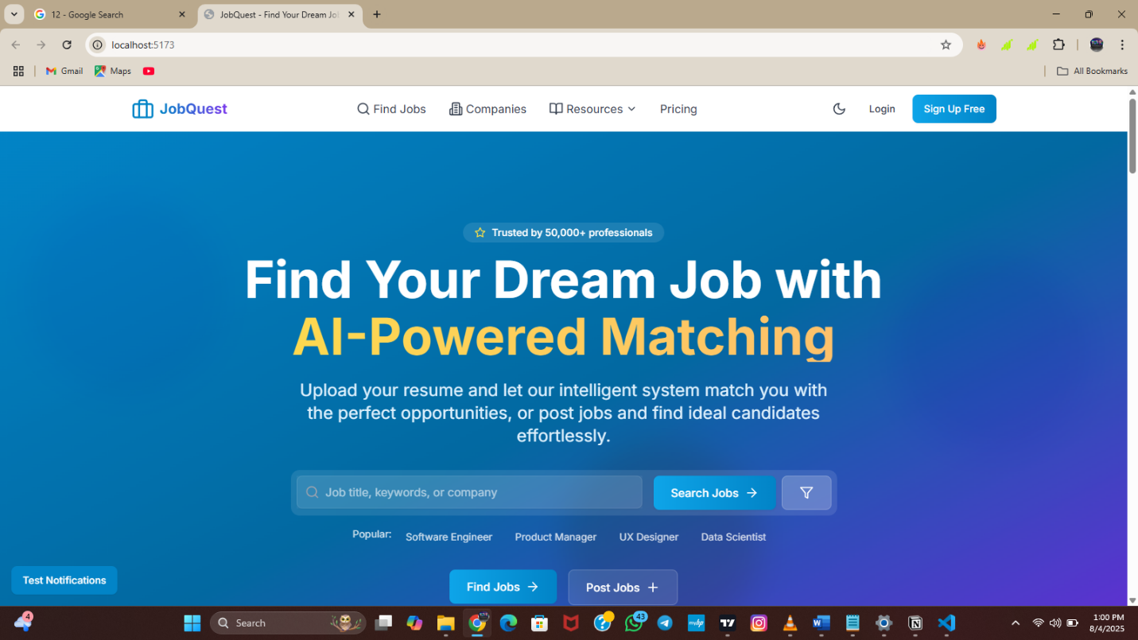

Login Page
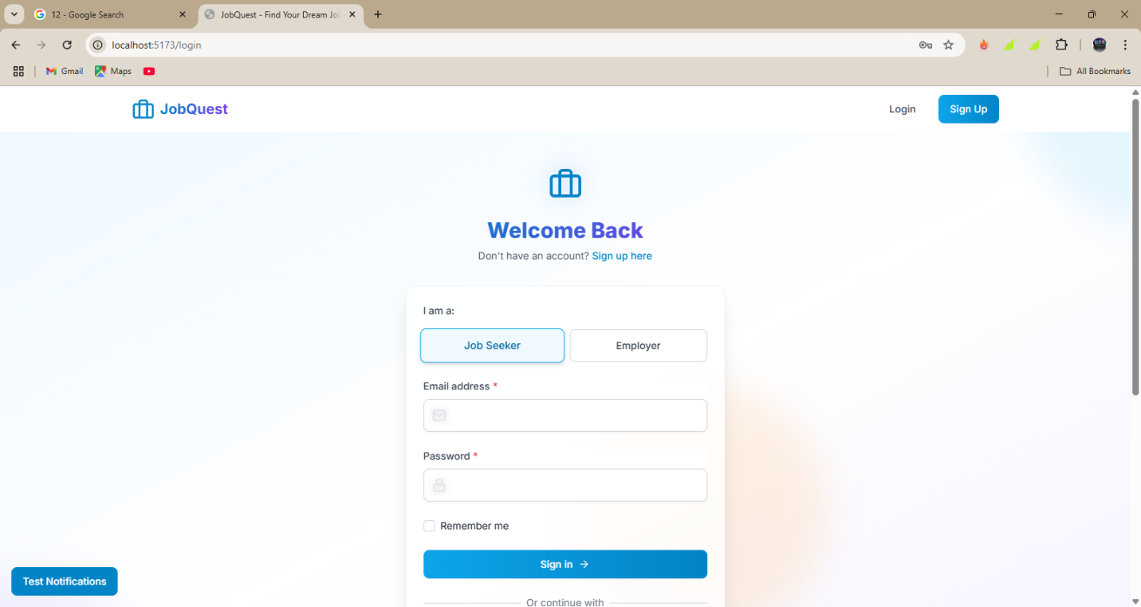

Signup page
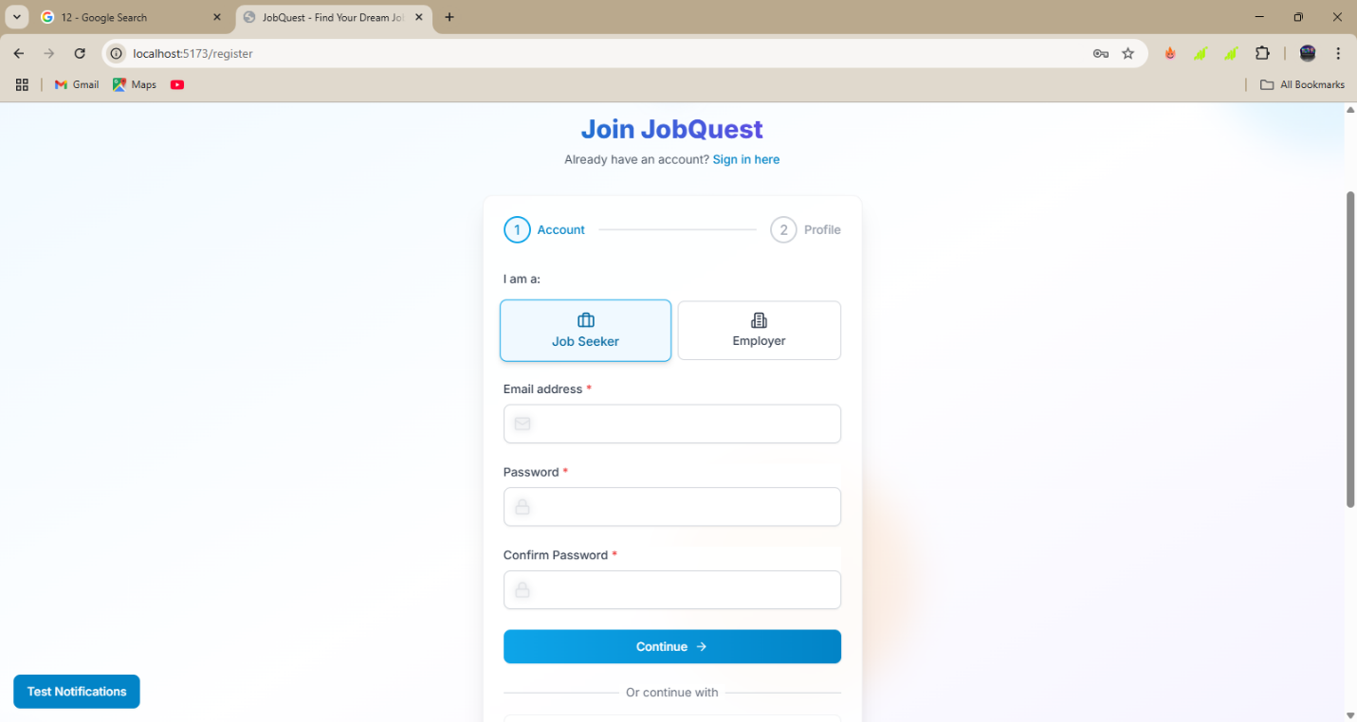

Home Page
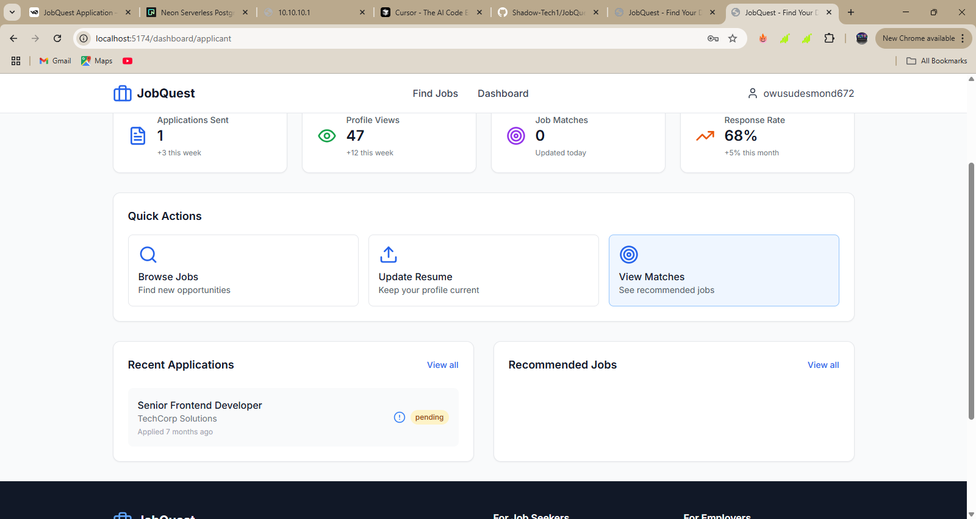

Find Jobs Page
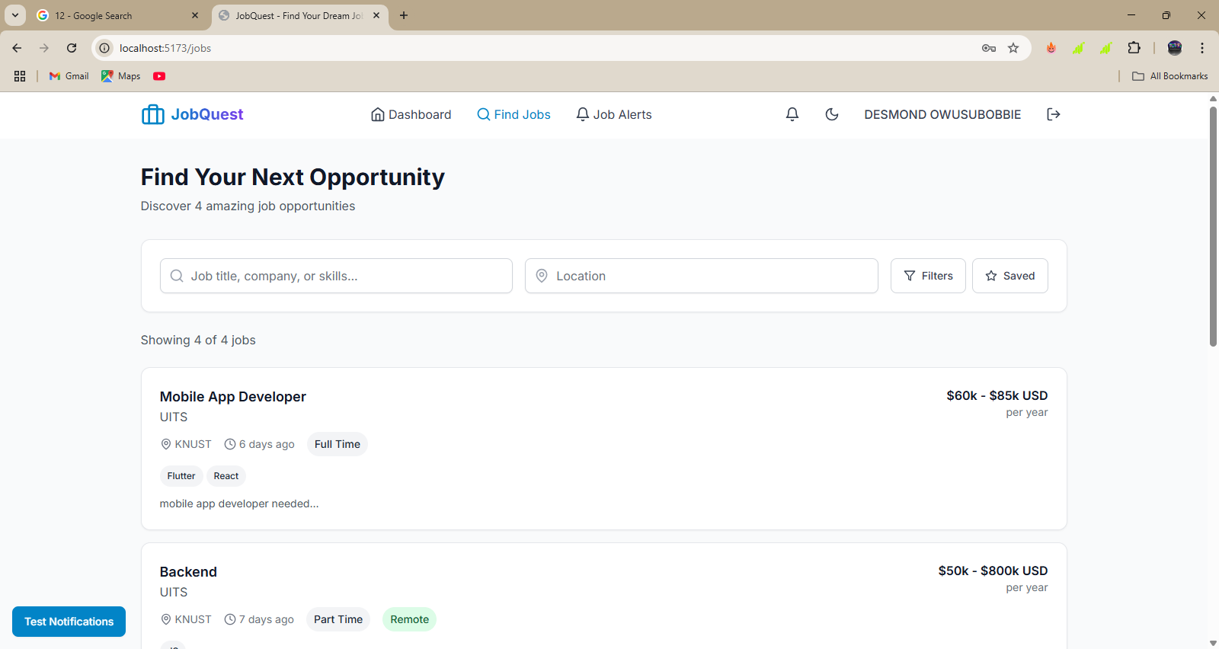

Applications Page
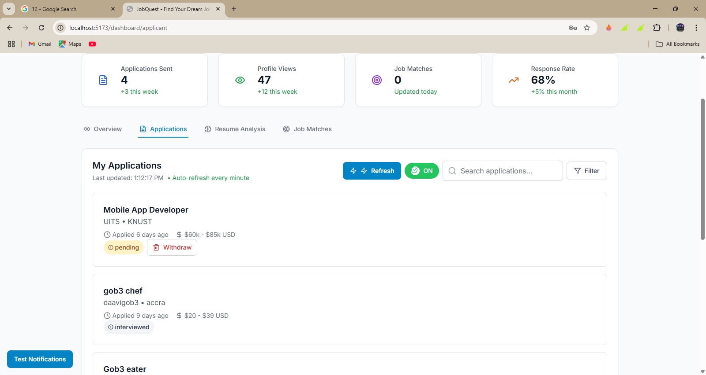

Resume Analysis Page
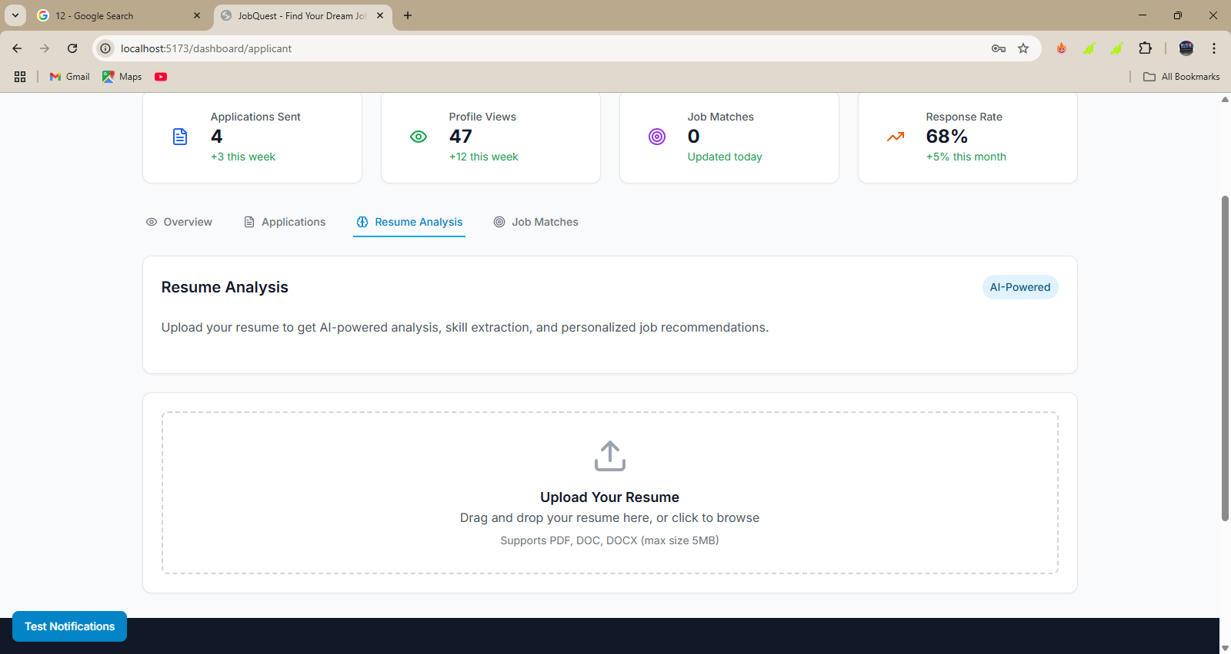

Job Matches Page
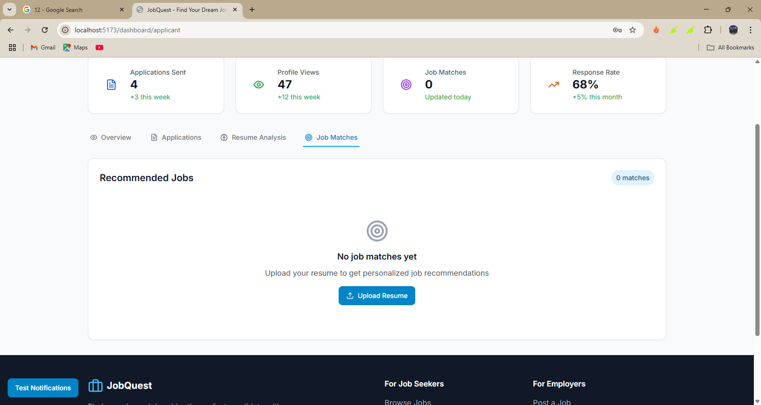

References
- https://react.dev/ ,accessed June 2025
- https://nodejs.org/en/docs/ , accessed June 2025
- https://www.mongodb.com/docs/ and https://mongoosejs.com/docs/ , accessed June 2025
- Related Works and Industry Analysis
- LinkedIn: https://www.linkedin.com/

